**JOHNSON, GEORGIA DOUGLAS (1877? -1966)**

Georgia Douglas Johnson was a multi-talented artist of the New Negro/Harlem Renaissance era who wrote poetry, plays, short stories, music, and newspaper columns from her home in Washington, DC. She was born in Atlanta, Georgia and was a member of Atlanta University’s Normal School class of 1893. She studied music at Oberlin College and wrote songs from 1908 until 1959.

By the time she was encouraged to try her hand at playwriting in the 1920s, she had already won recognition as a poet with two published volumes, *Heart of A Woman and Other Poems* (1918) and *Bronze: A Book of Verse* (1922). Later volumes were *An Autumn Love Cycle* (1928) and *Share My World* (1962). Known as ‘the lady poet’ of the Harlem Renaissance, Johnson’s poems have been variously described as ‘genteel’ (Fletcher), ‘modern feminist realism’ (Locke 79), and ‘modern Romantic’ (Primeau 265). Critics have noted her ‘feminine’ verses and highly gendered identity as a poet (McHenry 279-80), but a more courageous, innovative, and varied vision is seen in her plays. In addition to her lifelong devotion to poetry, she was one of the earliest African American women playwrights and, with twenty-eight plays (mostly one-acts), one of the most prolific of her era. Her early plays, such as *Blue Blood* (1926) and *Plumes* (1927), featured middle-aged black Southern women as central characters and located the action in their kitchens, thus placing a generally ignored population on the American stage. *Starting Point* (1938) is notable for representing a modern urban black family and for the character of Belle, one of the earliest portrayals of a female blues singer on the American stage. Johnson wrote a wide variety of plays and, as an artist/activist, she contributed her playwriting skills to the national anti-lynching movement. None of her lynching dramas were published until *Sunday Morning in the South* (1925) appeared in James Hatch and Ted Shine’s groundbreaking 1974 anthology *Black Theater, U.S.A.: Forty-Five Plays by Black Americans, 1847-1974.* Johnson was the most anthologized woman poet of the Harlem/New Negro Renaissance and today remains the most prolific playwright of the lynching drama genre.

In addition to writing poetry, plays, and music, Johnson served as an important cultural sponsor during the early decades of the twentieth century. Shortly after moving to Washington, DC in 1910, she opened her home as a gathering place where African American writers and artists could meet and exchange ideas in a safe, supportive, and welcoming environment. Johnson’s salon became a hub of activity during the Harlem/New Negro Renaissance and weekly gatherings of the self-described ‘Saturday Nighters’ included major Renaissance writers such as Langston Hughes, Jean Toomer, Jesse Redmon Faucet, Angelina Weld Grimké, and Zora Neale Hurston. In 1965 (one year before her death), Johnson was awarded an honorary degree as a Doctor of Literature from Atlanta University, and in a 2010 ceremony recognizing her contribution to the state’s rich literary heritage, she was posthumously inducted into the Georgia Writers Hall of Fame.

**Major Works**

*Heart of A Woman and Other Poems* (1918)

*Bronze: A Book of Verse* (1922)

*Sunday Morning in the South* (1925)

*Blue Blood* (1926)

*Plumes* (1927)

*An Autumn Love Cycle* (1928)

*Starting Point* (1938)

*Share My World* (1962)

Stephens, Judith L., ed. (2006) *The Plays of Georgia Douglas Johnson,* Champaign: University of Illinois Press.

Tate, Claudia, ed. (1997) *Selected Works of Georgia Douglas Johnson,* Boston: G.K. Hall and Company.

**References and Further Reading**

Fletcher, Winona. (1985) ‘From Genteel Poet to Revolutionary Playwright: Georgia Douglas Johnson,’ *Theatre Annual* 30: 41-64.

Hatch, James V., and Ted Shine, eds. (1974) *Black Theater, U.S.A: Forty-Five Plays by Black Americans, 1847-1974*, New York: Free Press.

Hull, Gloria T. (1987) *Color, Sex and Poetry: Three Women Writers of the Harlem Renaissance,* Bloomington: Indiana University Press.

Locke, Alain. (1928; 1997). ‘Foreword to *An Autumn Love Cycle*, by Georgia Douglas Johnson,’ in *The Works of Alain Locke*, ed. Charles Molesworth, New York: Oxford University Press. 79-80.

# McHenry, Elizabeth. (2002) *Forgotten Readers: Recovering the Lost History of African American Literary Societies*, Durham, Duke University Press.

Perkins, Kathy A., and Judith L. Stephens, eds. (1998) *Strange Fruit: Plays on Lynching by American Women*, Bloomington: Indiana University Press.

Primeau, Ronald. (1972) ‘Frank Horne and the Second Echelon Poets of the Harlem Renaissance,’ *The Harlem Renaissance Remembered*, ed. Arna Bontemps, New York: Dodd Mead. 247-67.

**Judith Stephens-Lorenz, The Pennsylvania State University**

**Recommended Illustrations**

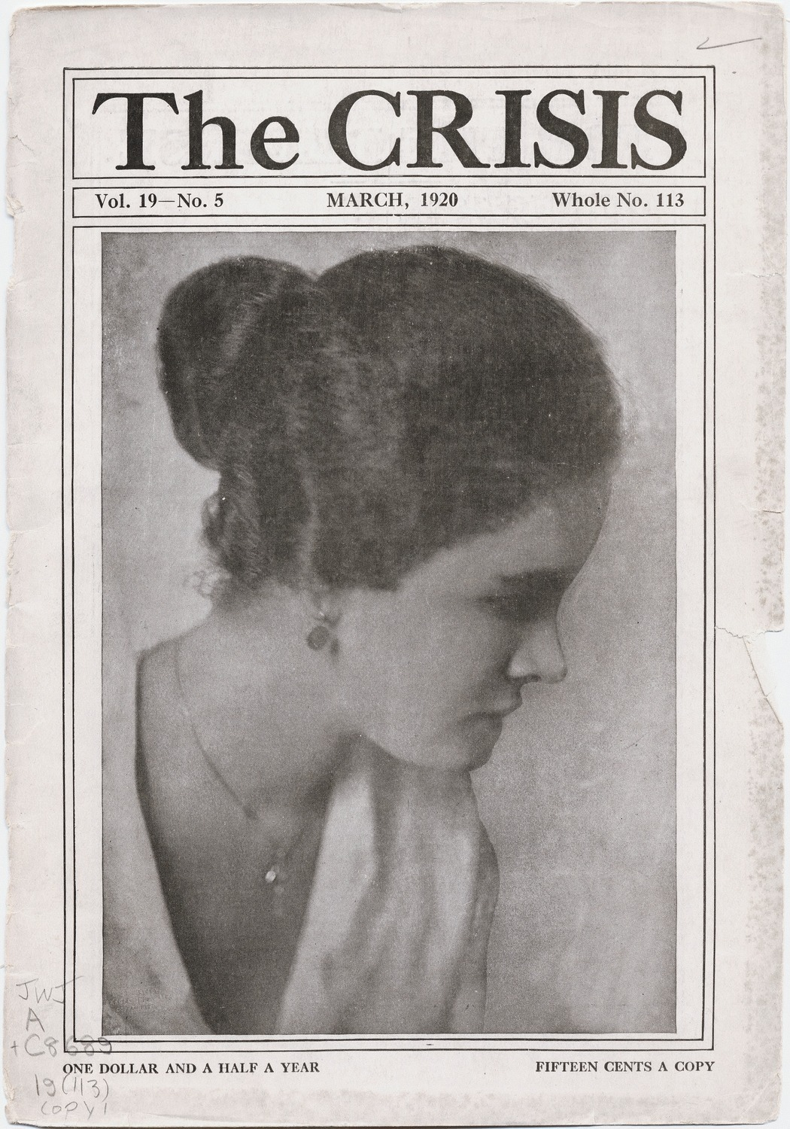

**Georgia Douglas Johnson**

[available at Yale University, Beinecke Rare Book and Manuscript Library: <http://brbl-dl.library.yale.edu/vufind/Record/3520460?image_id=1014268>]

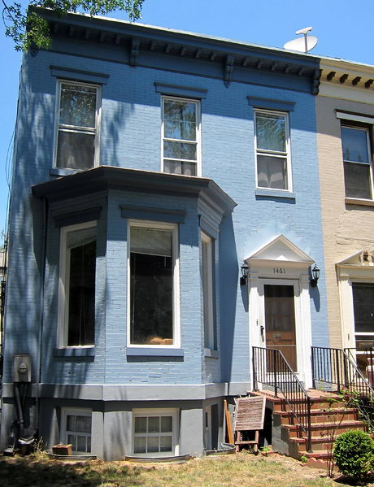

**Georgia Douglas Johnson’s house at 1461 S Street NW in Washington, DC, where she hosted an important literary salon during the Harlem Renaissance.**

**[available at: <**[**http://en.wikipedia.org/wiki/Georgia_Douglas_Johnson**](http://en.wikipedia.org/wiki/Georgia_Douglas_Johnson)**>.]**

**[There is another very similar photo (perhaps less high-quality at <**[**http://www.historydc.org/UserFiles/file/HistoryMinute/HM%20April%202008.pdf**](http://www.historydc.org/UserFiles/file/HistoryMinute/HM%20April%202008.pdf)**>.]**

**The author of the entry also sent me a powerpoint slide with a black and white photo of the house by retired theatre scholar Kathy Perkins. If you would like this image and perkins’s contact information, please let me know.]**